Patron
IRePliP

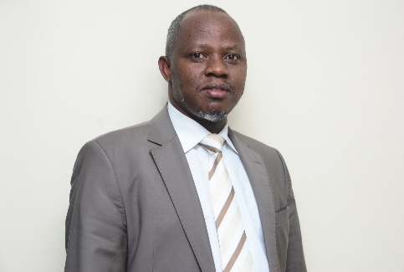
Dr. Linus Maundu Muli, PhD
IRePLiP Board Chair and a Visiting Fellow at Machakos University, Kenya.


Mr. Chris Masimo
IRePliP Board Member
Centre for Rural Economy, Uganda

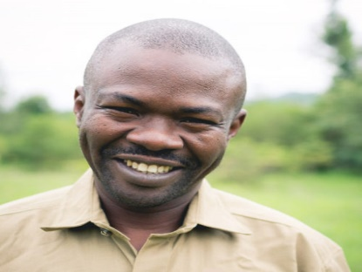
Mr. Mabuto Kwabisa
IRePliP Board Member
Community Global Advisor, South Africa


Dr. Emmanuel Obianuju Chiamaka, PhD
IRePliP Board Member
National Horticultural Research Institute, Nigeria


Ms Diana Blu
IRePliP Board Member
EDR Group, USA


Prof. Shunichi Shoshum, PhD
IRePliP Board Member
Research Scientist

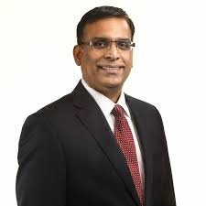
Rev. Smith Vernon
IRePliP Board Member
Phenomenology of Religion and Bio-ethics, Japan

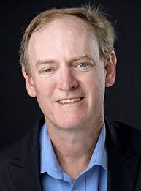
Dr. Christiph Markschies, PhD
IRePliP Board Member
Development Economics Centre, German

